BEFORE HAUL OUT:
- Top off Diesel Tank before hauling- add fuel stabilizer & Biocide
- Pump seawater through heads overboard- clean out all lines
- Remove Sails
- Remove all Soda- diet/w/o sugar will freeze & explode
- Remove all spare propane bottles (Grill)
- PULL SPEED SENSOR- or it will be crushed by the travel lift!
- RV Antifreeze- Used 12 gallons winter 2021
ENGINE (2 gal)
- Change Engine Oil & Filter (while hot) Cap 6-7 Quarts Hoses
- Change Transmission Fluid Cap ~1.5 Quarts Dextron III Mercon
  - Don’t screw in dipstick to read level, use paper towel to read level.
- Change Fuel Filters Engine (every 2 years: 2015/2017)
- Drain water from Racor Filter
- Air intake- clean
- Pull Strainer on raw water Strainer & Clean, Vacuum out water
- Check: Belts, Hoses, Motor Mounts
- Pull Raw Water impeller **REPLACED SPRING 2021**
- Pull Raw Water Intake- Flush with 2 Gal of Glycol Antifreeze
  - Check exhaust
  - Leave disconnected until finished with A/C system
  - Blow out seacock with air while opening/closing
  - Drain Seacock (remove plug)
- Plug Exhaust port (transom) with Rag
- batteries- Charge and Then Disconnect
Water Tanks (4 Gal ALL without engine)
- Drain Fwd, Port and Stbd tanks using 12v pump.
- Vacuum out Port and Stbd Tanks to remove remaining water.
- Remove fresh water strainer & cover- Apply shop vac here and open up P&S & FWD tank lines to remove all water in the lines between the tanks and the manifold.
- Use Air Compressor to blow out water in lines/plug in adapter/bypass pump
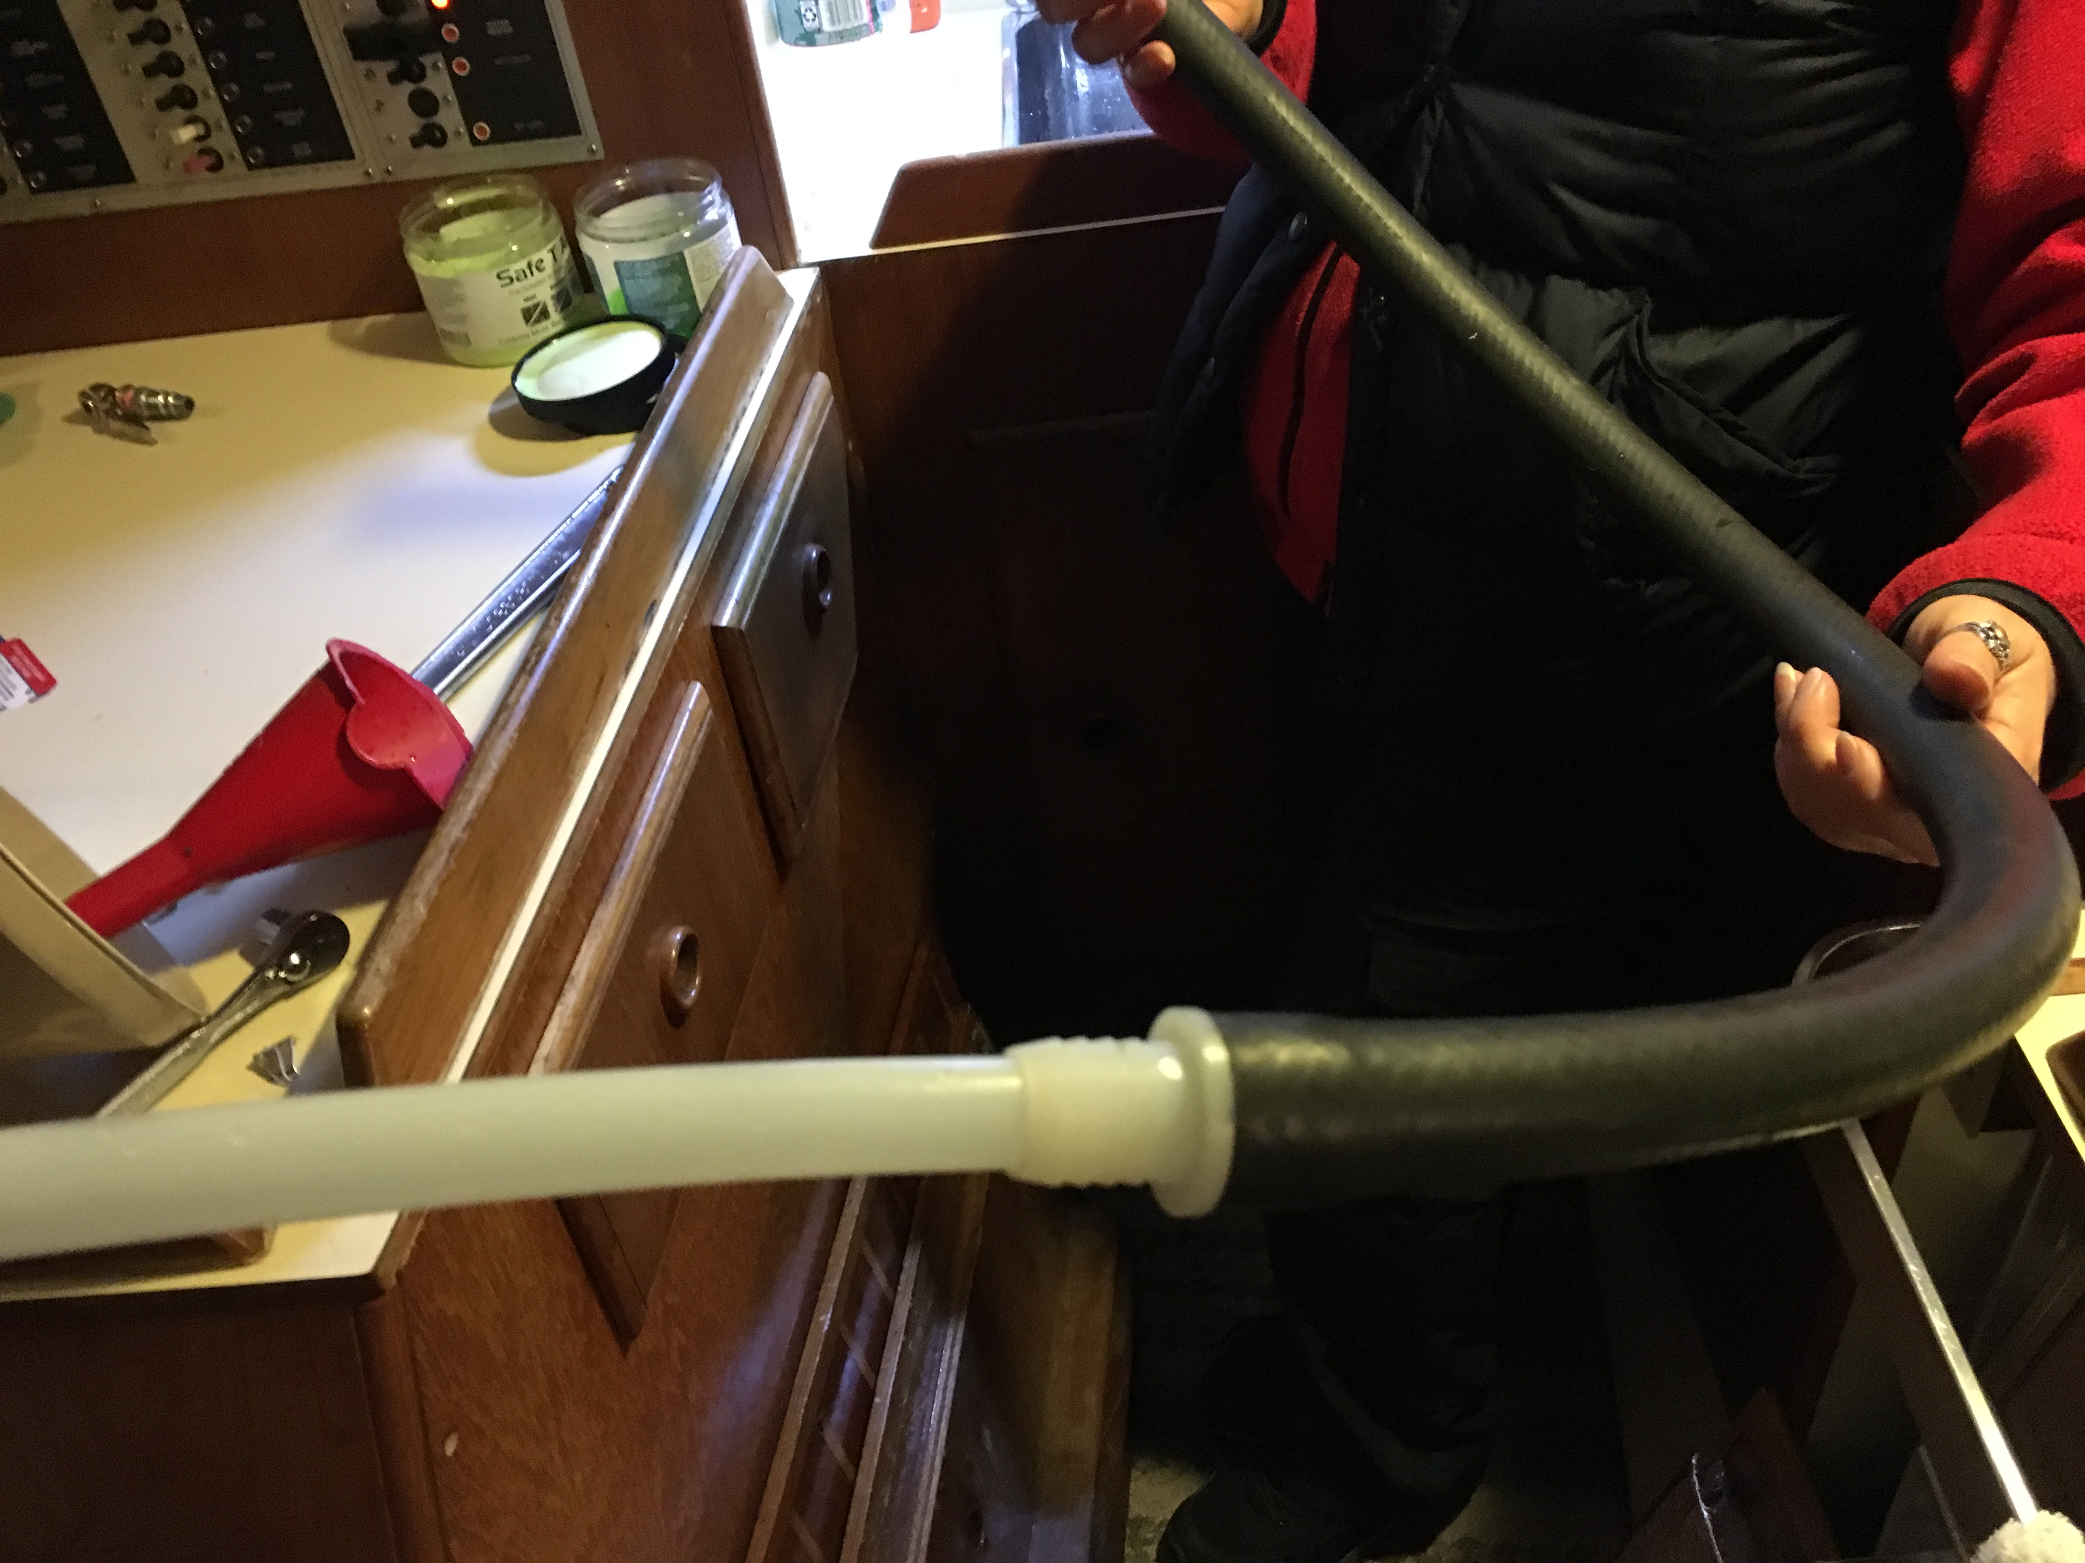
- Use air to empty water heater- open drain on aft end of Water Heater use pex/hose to galley sink. Blow out remaining water while red bypass valve is open.
- Put Hot Water Heater line into bypass mode.
- Clean strainers for Fresh water and sump
- Close Port & Stbd valves, open Center valve for Forward tank.
- Using the deck fill, fill forward water tank with 4 Gallons of antifreeze.
- Unplug Water Heater, Plug in Engine Room Heater
- Switch water pump on and Run water to
  - Aft Head and Shower until Pink, Fwd Head until Pink
  - Galley sink until Pink
  - Let some into the water heater (via bypass valves)
A/C Unit (3/4 gal)
- Option 1
- NEW 2015 (could not get to work fall 2017)
- Pull cap off “T” under Nav Station
- Use ¾” hose to blow water out of pump/strainer/seacock
- Close seacock and blow water out of A/C Unit
- May not have to use antifreeze in A/C Unit.

- Option 2 (used fall 2021)
- Pull A/C Coolant Hose
- Put Funnel into hose and Run Pump to circulate Antifreeze (3/4 gal)
- Leave running & pull and clean the strainer
- Blow out seacock with air while opening/closing valve
- Reconnect the hose and then turn off the AC unit. (Do this QUICKLY).
Fwd Seacock intake to Washdown Pump (1/2 gal)
- Pull hose & Run Washdown Pump until pink. (1/2 gal)
- Clean strainer in fwd anchor locker.
- Blow out seacock with air while opening/closing valve- leave closed. 5/8”
- Drain Seacock (remove plug)
Fwd Head- (2 gal)
- Turn Diverter valve to Overboard (~1 ½ gal)
  - Pump fast until air comes out of seacock (open and close seacock quickly to get all water out of seacock).
  - Note: If this works then you only need 1 GAL. If not two.
  - Put ½ gal Antifreeze into bowl and pump overboard w/air
  - Drain Seacock (remove plug) make sure you see red antifreeze
- Turn Diverter valve to TANK (~ ½ Gal)
  - Put funnel into water intake on head (remove plug)
  - Pump (½- 1 gal?) Antifreeze thru head into holding tank.

Aft Head- (1-2 Gal)
- Turn Diverter valve to TANK (normal position)
  - Put funnel into raw water intake for head.
  - Pump (1 gal) Antifreeze thru head into holding tank.
  - Blow out raw water intake for head with hose/mouth.
  - Remove seacock drains for intake and overboard.
- ONLY IF DIVERTER WAS SET TO OVERBOARD THAT SEASON:
- Turn Diverter valve to Overboard
  - Pump fast until air comes out of seacock (open and close seacock quickly to get all water out of seacock).
  - Put 1 gal Antifreeze into bowl and pump overboard w/air
  - Drain Seacock (remove plug) make sure you see red antifreeze
  - Drain raw water intake Seacock (remove plug)

Refrigerator Drain
Antifreeze into Refrigerator Drain (Use Antifreeze from Galley Sink)
Galley Sink
- Metal tape on port side cockpit drain to plug drain.
- Disconnect Engine room bilge pump hose & plug opening
- Rag & Shop vac on sink drain, blow air into seacock under sink and open and close port cockpit drain a few times to remove water.
- Leave port cockpit seacock closed
- Cycle seacock under sink to ensure it is drained
- Remove fuse for Aft bilge pump & reconnect drain line.

Misc
- Cockpit Drain Seacocks in Engine room- Exercise and leave starboard seacock open. Port seacock stays closed (to sink/engine bilgepump)
- Remove Bimini & Tie up supports
- Pull engine hoist and install plug on top
- Remove davits, leave in cockpit
- Wash down Deck & boat- check for any leaks – ports/etc
- Winter Cover- Install & Tie Lines OUTSIDE cover to keep it from inflating
- Re-Energize moisture absorbent pouches

If Pulling the Mast
- Remove Windex & Wind Instruments at masthead,
- Remove VHF Antenna
- Disconnect all electrical connections at mast step.

BEFORE HAUL OUT LOAD ON BOAT:
- Shop Vac, Hoses, Connector, Extra Filter
- 300’ garden hose & nozzle to wash down boat
- 100’ extension cord
- ladder & lock (chain)
- Anti-freeze bottles
- oil changer pump
- oil container for old oil
- oil for oil change & filters
- winter cover and supports (PVC Tubing and wood base)
- rug to cushion boat in slings
- Blower to clean off Decks
- Tool Pouch w/hammer, large punch to remove centerboard
- 4’ plastic Level (Attach to rudder to level boat)

Parts Needed for Winterization:
Fuel Filters (Yanmar P/N 129470-55701 & Racor p/n 2010SM)
Oil Filter (Yanmar p/n 129150-35150)
2 Qts ATF Dextron III Mercon
2.0 Gal 15w-40W Oil
12 Gal Glycol Antifreeze (Non-Toxic) used 12 gal 2014
Fuel Stabilizer

Spring Cleanup:
Grease Max Prop & Install new Zinc on prop and two 1 ¼” Zinc’s on the shaft
Spray Antifoulant on Prop
Paint Bottom Ablative (1 gal just covers) 2007- three Gals gave two coats
Three gallons of Micron Extra gave two coats & to centerboard w/ ½ gal left
Used ¼” Nap roller for boat. 9x6 Green Scrub Pads to wet sand hull
Wax Boat
Bring to Boat before launching:
6 Rug strips for travellift (Oak Harbor has good pads)
Davits (attic garage)
Dink
Sails
GPS, Binoculars – any electronics taken off the boat for the winter
Prep for Launch:
Reconnect Batteries
Remove Plug Exhaust port (transom) Rag
Check Transmission Fluid Cap ~1.5 Quarts Dextron III Mercon
Check Engine Coolant
Check Engine Oil
Check Raw Water Impeller (replace/reinstall) replace spring 2015
Clean Raw Water Strainer washdown pump
Check Belt Tension Alternator/Water Pump
Check Stuffing Box/ PSS Shaft Seal for wear
Spare Propane back to boat (Grill)
Cushions Back to boat
Sails on board
GPS / Binoculars / VHF / Charts
Dive Gear back on board
Just before launch:
Pull Backstay for TravelLift (Not Necessary at Oak Harbor)
Dink on davits
Crank up Centerboard
Close all seacocks
.
After Launch:
Burp PSS Shaft Seal (get air out)
Flush Water tanks
Replace water filter
Hose out Bilge and Flush
Light lubrication on Turnbuckles
Check Rigging Tension

